Insertion:

2.

3.

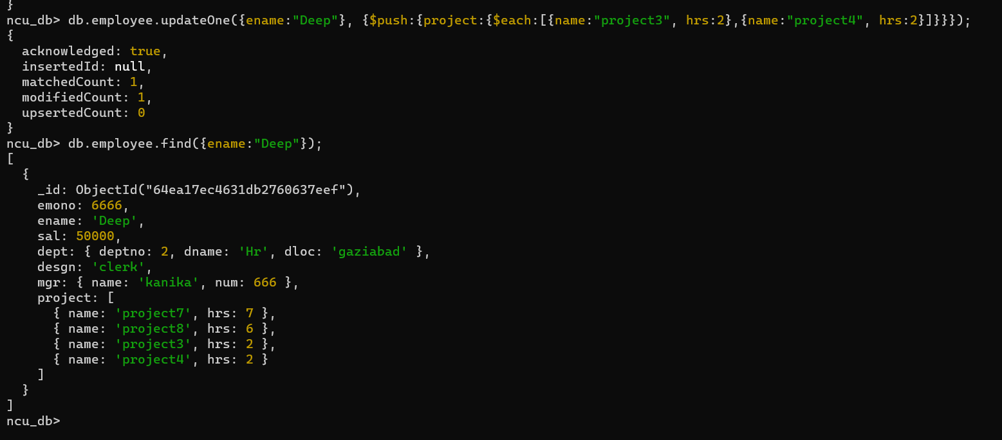

4.

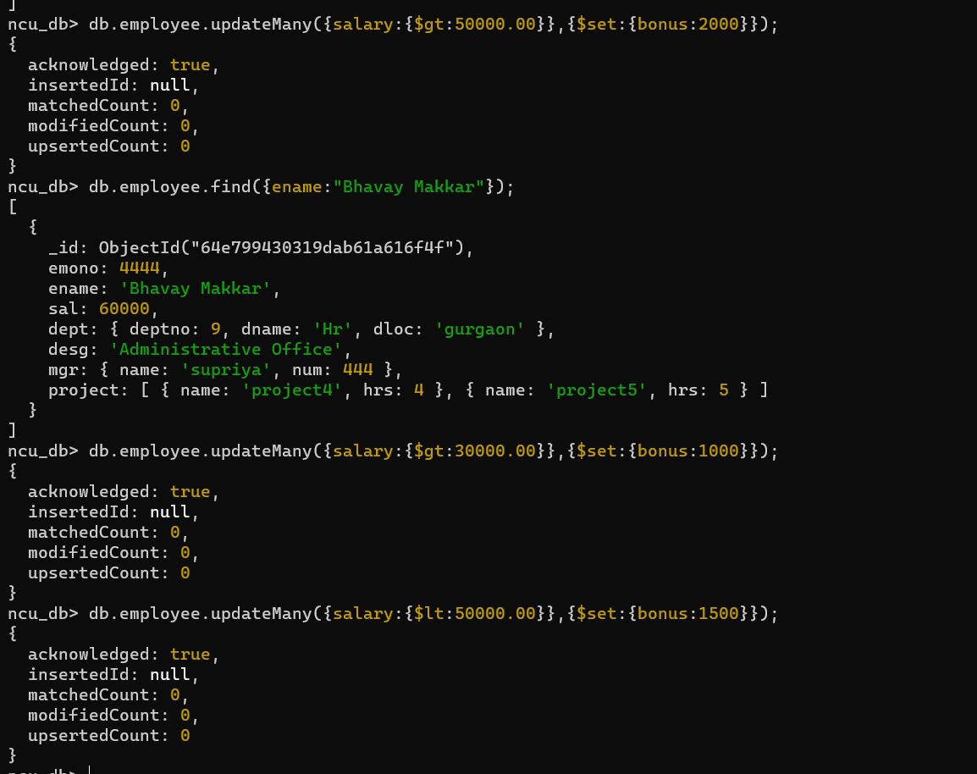

5.

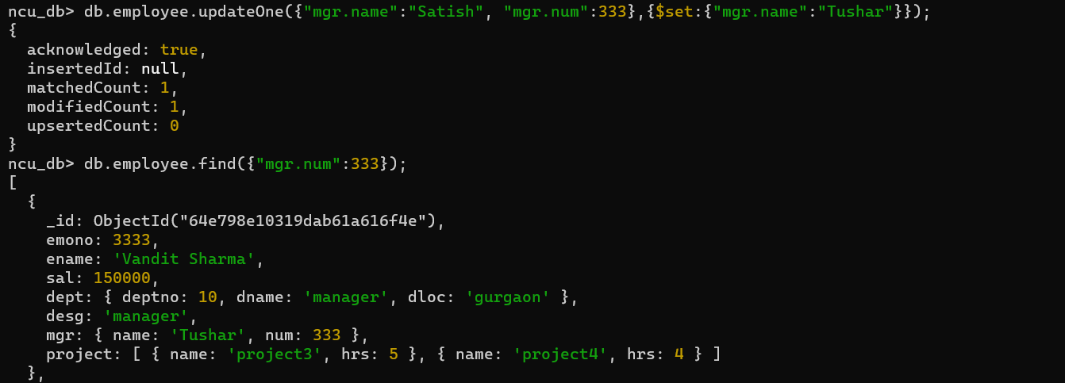

6.

7.

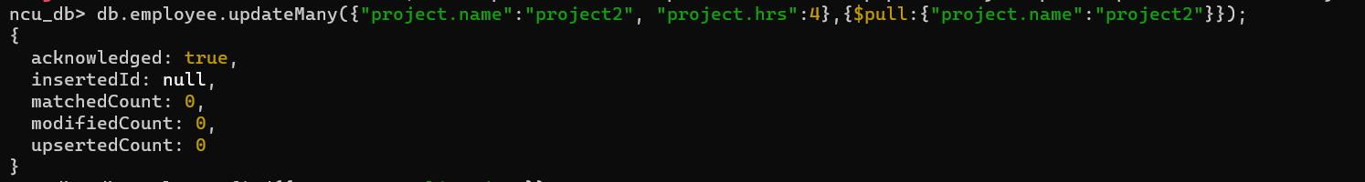

8.

9.

10.

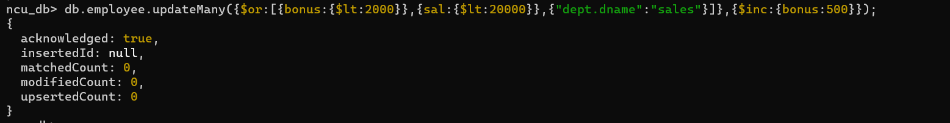

11.

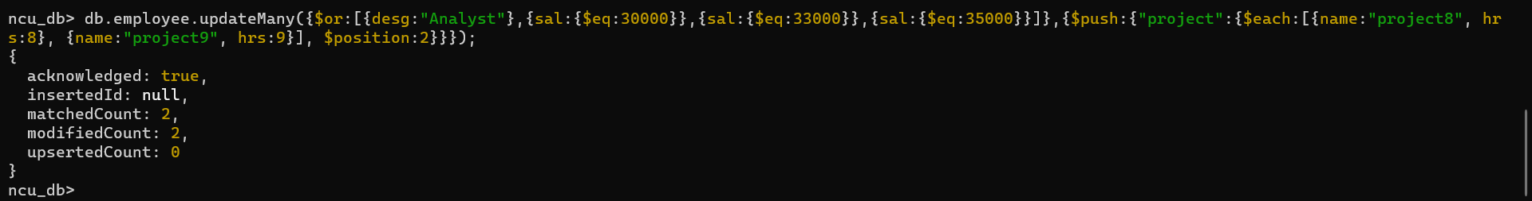

12.

13.

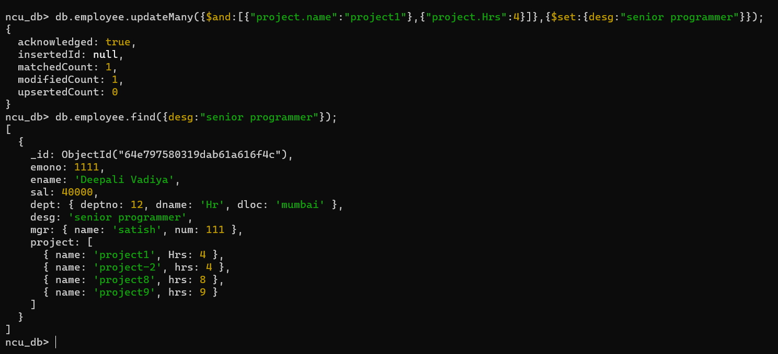

14.

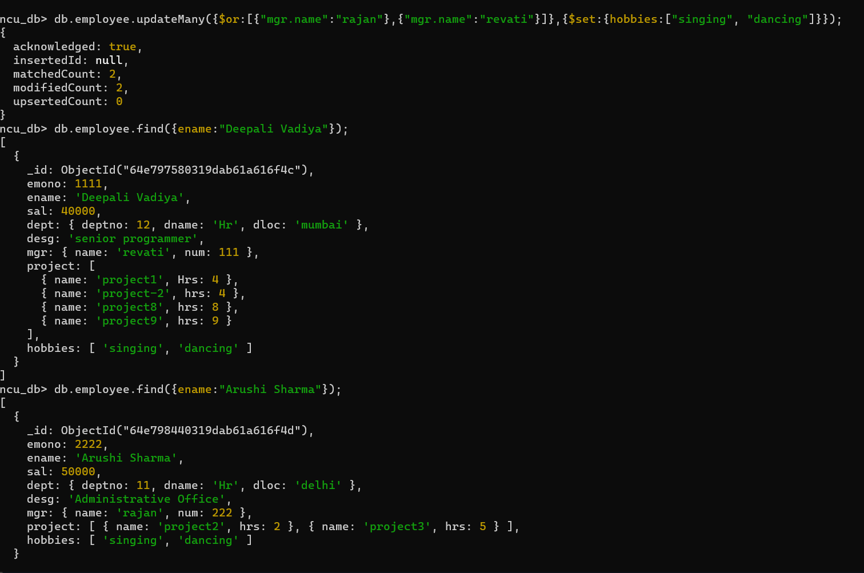

15.